Parameter search for SNF 0M8 and 1M8

Goal: To find default parameter sets for SNF 0M8 and 1M8 such that the Ptot value is minimized with enough oscillatory region to meet the 5-point criteria

1. SNF 0M8

Initial guess

At0 = alpha = 10, Vmax=4, Km=3, Kd=1

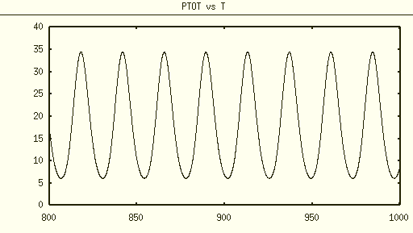

max(Ptot) ~ 35, relative amplitude ~(35-5)/(35+5) = 0.75, dimensional Kd = 100/35~ 3nM

Write cost function in the following way

cost = Ptot_max + 10/amp*( amp < 0.2 );

The returned parameters are

At0 = 9.8, alpha = 9.3, Vmax=3.2, Km=3.9 (fval~30)

I’ve also tried to vary the coefficient 10, and the returned parameters are pretty much the same, max(Ptot)~ 20.

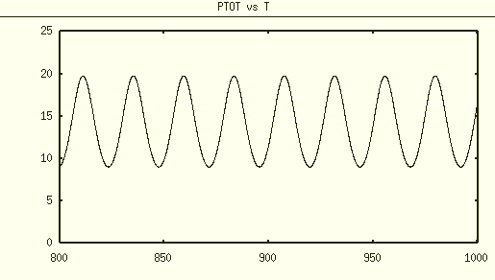

Ptot = 20, relative amplitude = (20-10)/(20+10) = 0.33. dimensional Kd = 100/20 ~5 nM

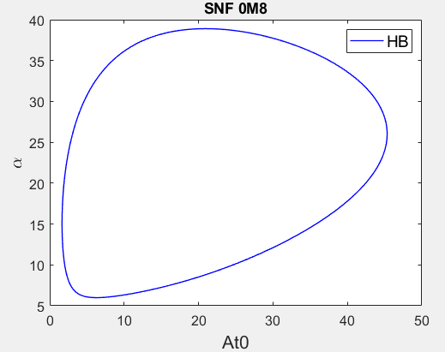

I think the oscillatory region is large enough to meet the 5-point criteria.

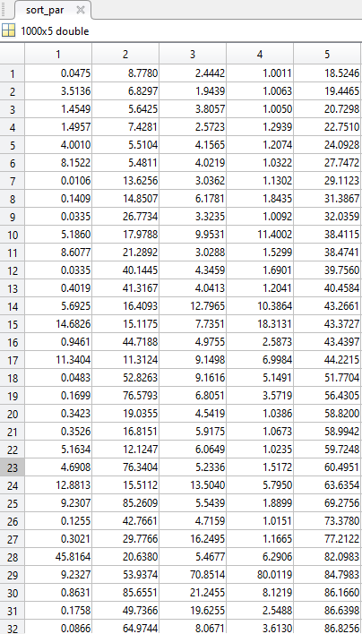

ID 1

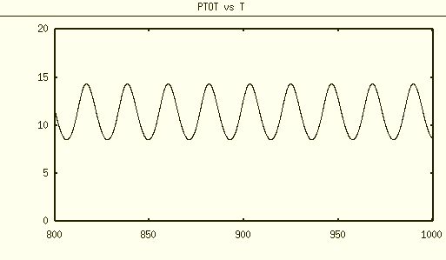

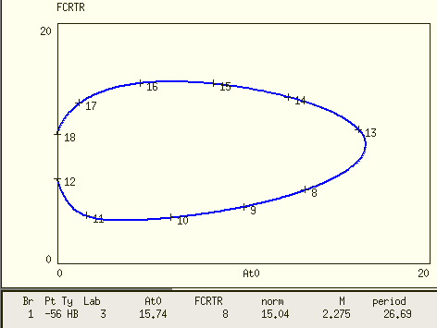

5-point criteria seems be met with some difficulty.

Id 2

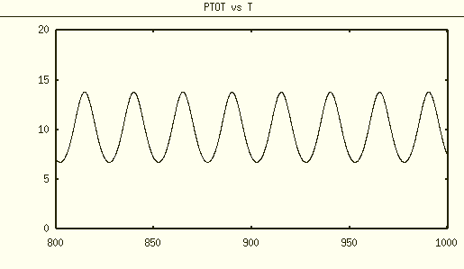

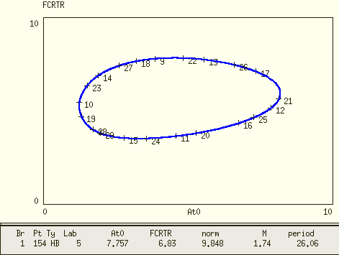

Id 3

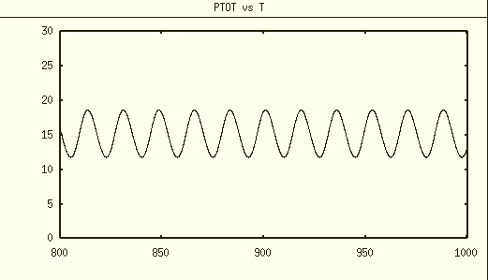

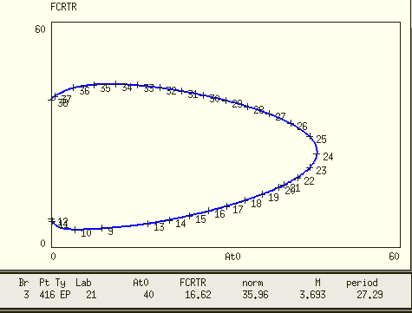

5-point criteria seems be met.

Id 4

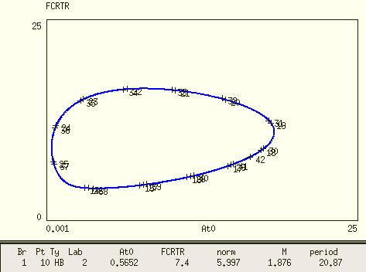

Id 5

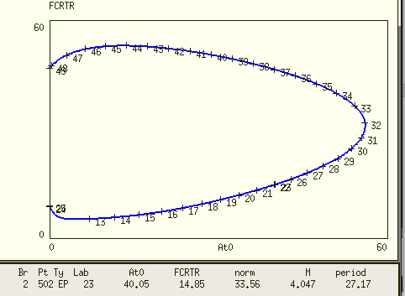

5-point criteria seems be met.

2. SNF 1M8

1) Below is the parameter set originally found for SNF 1M8

Kd = 0.3, At = 6     alpha = 6    Vmax=1.3    Km=1 Ka=1

Now we scaling with respect to Kd (Kd=1), therefore

Kd = 1, At = 19.8, alpha = 19.8, Vmax = 4.3, Km = 3.3, Ka=3.3

Use this parameter set as the initial guess, and the optimization result is

Kd = 1, At = 19.8, alpha = 19.7, Vmax = 3.8, Km = 3.7, Ka=3.4

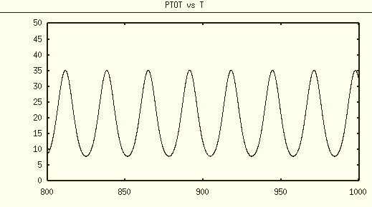

max(Ptot) = 35, dimensional Kd ~ 3

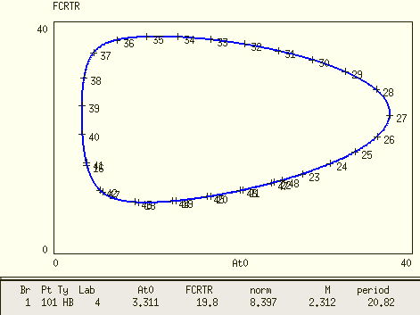

The oscillatory in At0-alpha plane does expand a lot, and the 5-point criteria can be met.

2)

To explore how the Ptot value and At0-alpha oscillatory region vary with different parameter values, I did a random parameter sweeping for the initial guess of the optimization algorithm. Latin hyper cube sampling is used to form the initial guess matrix containing 1,000 parameter sets. I selected 9 parameter sets with the smallest cost function below to check their Ptot value and the corresponding oscillatory region.

|  |  |  |  |  |  |  |
| --- | --- | --- | --- | --- | --- | --- |
| ID | At0 | Alpha | Vmax | Km | Ka | cost |
| 1 | 1.793627 | 13.78051 | 2.09672 | 1.012414 | 1.997332 | 19.71625 |
| 2 | 0.164417 | 55.61055 | 3.026435 | 1.049239 | 1.071904 | 20.6514 |
| 3 | 2.566445 | 25.65666 | 2.977012 | 2.085698 | 3.837483 | 25.93812 |
| 4 | 0.550649 | 78.08536 | 2.644244 | 1.006375 | 2.660055 | 26.21802 |
| 5 | 5.877851 | 16.90405 | 2.4576 | 1.007209 | 2.003643 | 32.4533 |
| 6 | 7.933545 | 21.50294 | 4.422015 | 5.976318 | 2.546341 | 39.57671 |
| 7 | 8.265877 | 28.18556 | 6.152982 | 1.000179 | 20.94345 | 41.38892 |
| 8 | 15.19754 | 22.74202 | 5.054122 | 5.461164 | 19.9787 | 43.06006 |
| 9 | 13.61066 | 12.92118 | 9.33856 | 4.166689 | 1.009893 | 56.46914 |

The 1st parameter set with the lowest cost in Xpp has a relative amplitude ~0.5

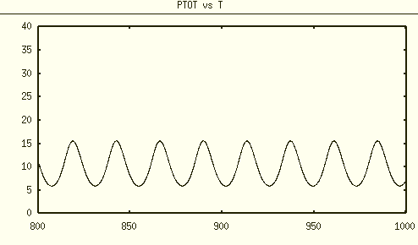

If choose

|  |  |  |  |  |
| --- | --- | --- | --- | --- |
| At0 | Alpha | Vmax | Km | Ka |
| 1.8 | 14 | 2 | 1 | 2 |

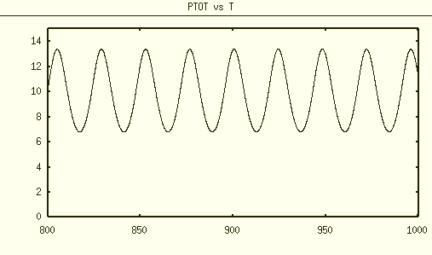

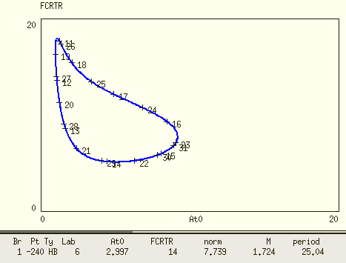

However, the oscillatory region cannot meet the 5-point criteria.

The 2nd parameter set

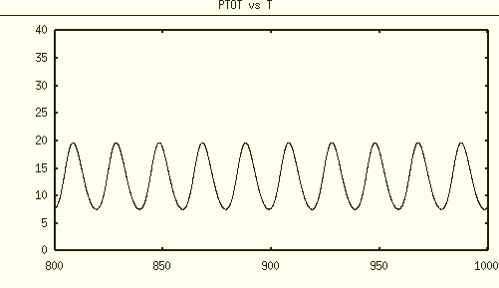

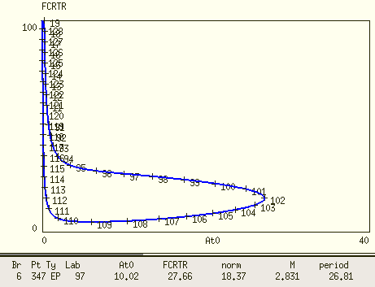

The 5-point criteria seem to be met.

The 3rd parameter set

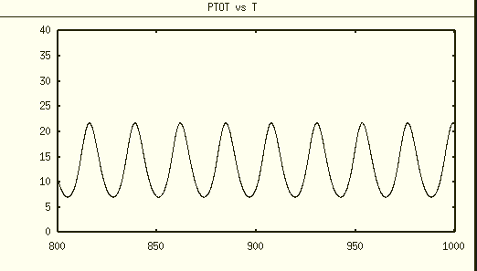

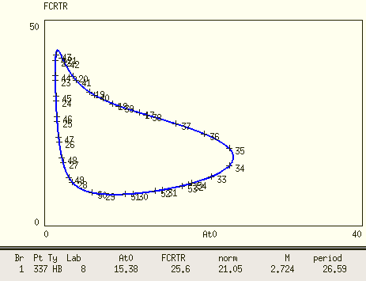

The 4th parameter set

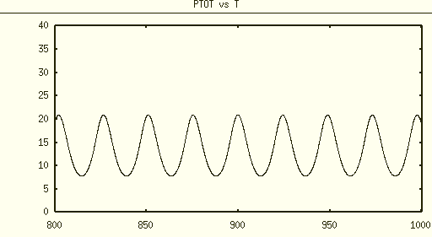

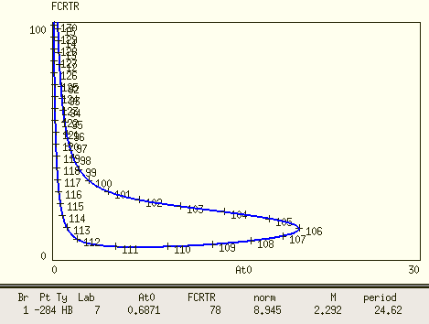

The 5th parameter set

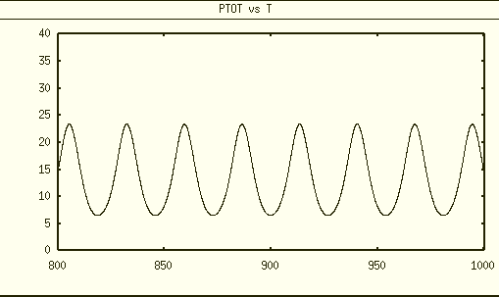

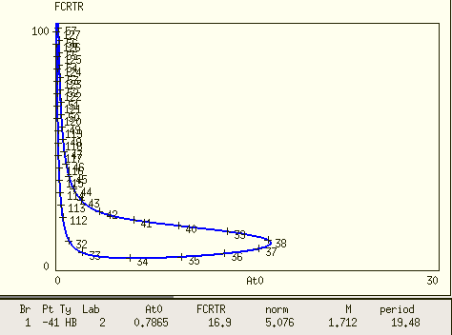

The 6th parameter set

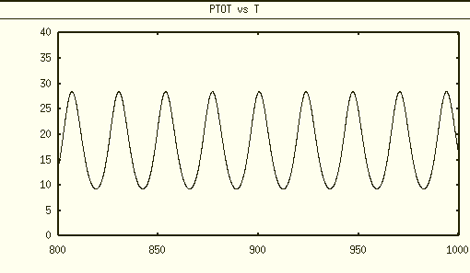

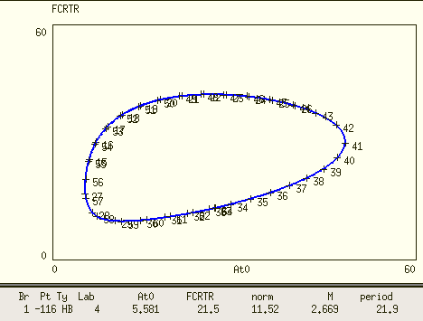

The 7th parameter set

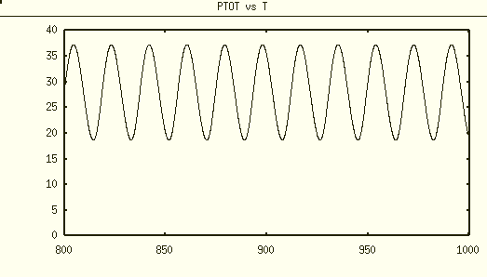

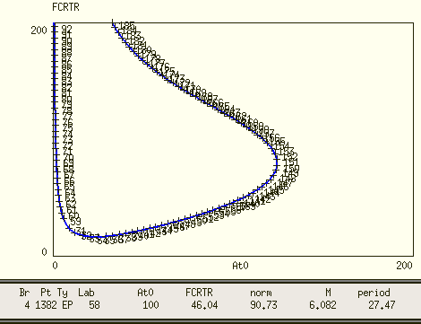

The 8th parameter set

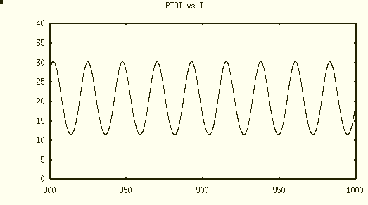

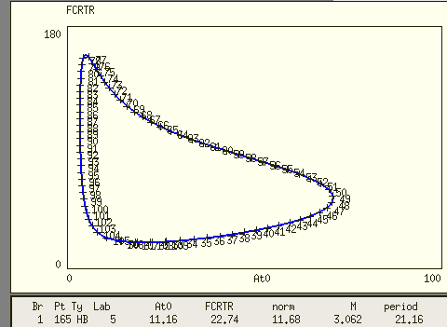

The 9th parameter set

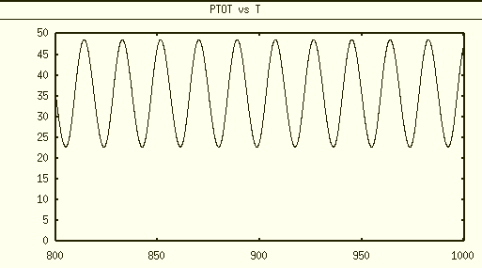

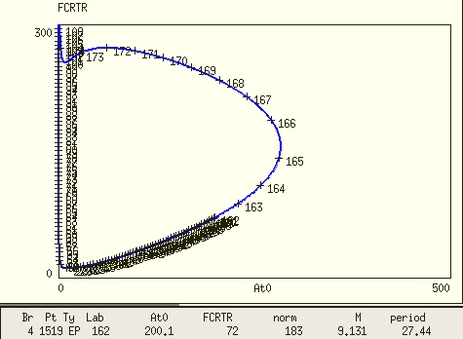

Conclusion

1. For SNF 0M8

At0 = 9.8, alpha = 9.3, Vmax=3.2, Km=3.9 has a max(Ptot)~20 with a oscillatory region big enough for 5-point criteria



2. For SNF 1M8

Multiple parameter sets exist for similar small max(Ptot) and oscillatory region. There definitely is a trade-off between small Ptot and large oscillatory region. So far, I prefer the 8th parameter set

At0 = 15, alpha = 22, Vmax=5, Km=5.5, Ka=20, which can meet the 5-point criteria and it has max(Ptot)~30.

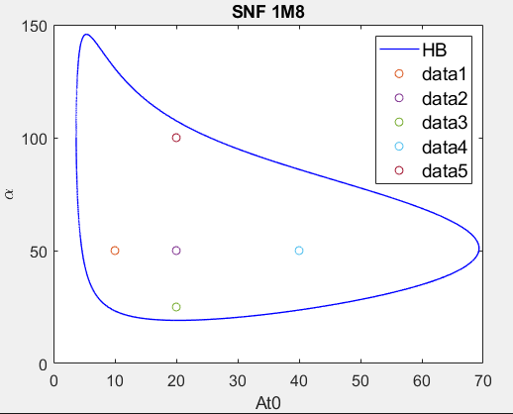

If use this parameter set (the purple dot for diploid strain At0=20, alpha=50) for SNF 0M8 (ignore Ka)

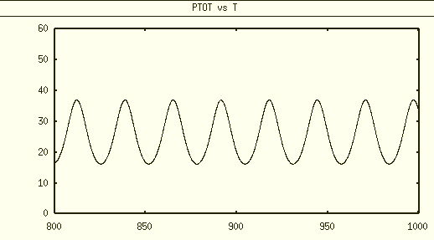

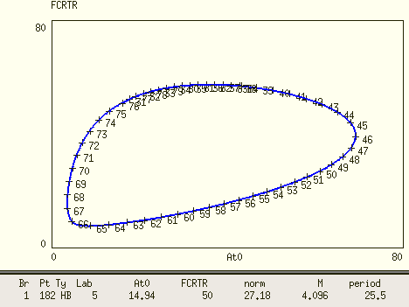

The oscillatory regions seems fine for SNF 0M8.